HOW TO GENERATE A NEW CONTRACT

- Go to the HOME page
- Scroll down to the event and then sponsorship that you want to sell.
- If you look to the right, you will see if it is available or not.
- Click the underlined sponsorship name
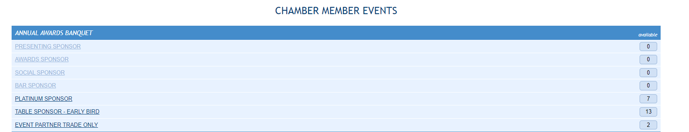
- You will see this screen. Click View/Print Contract.
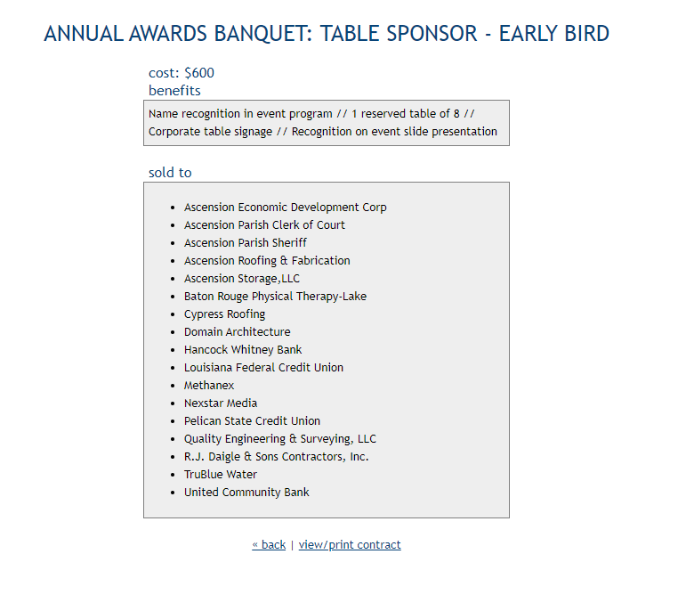
- Fill out the information on the next screen. If you plan to use the E-Signature option, put YOUR EMAIL in the email box.
- Click Create Contract
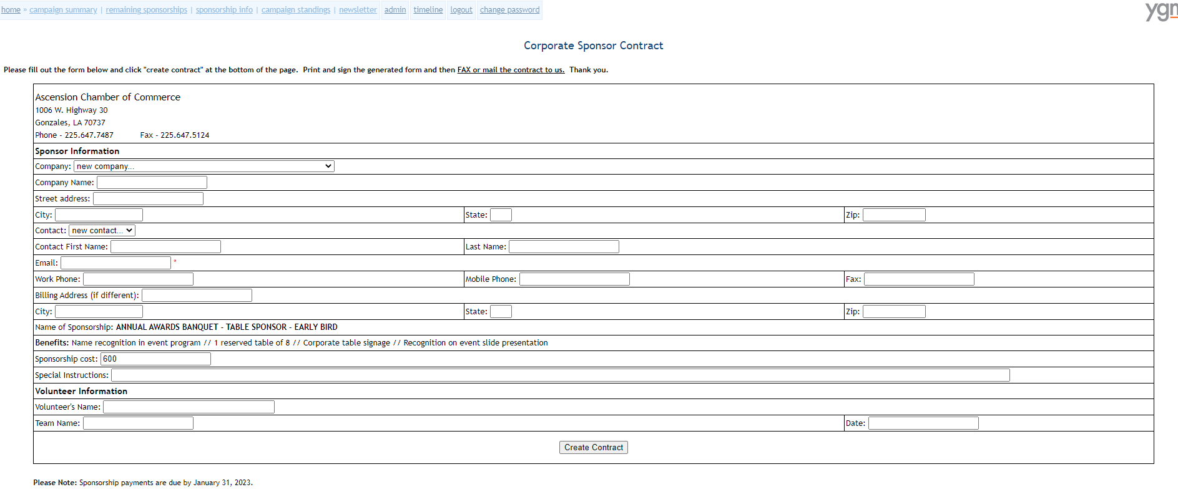

THERE ARE 4 OPTIONS AT THE TOP
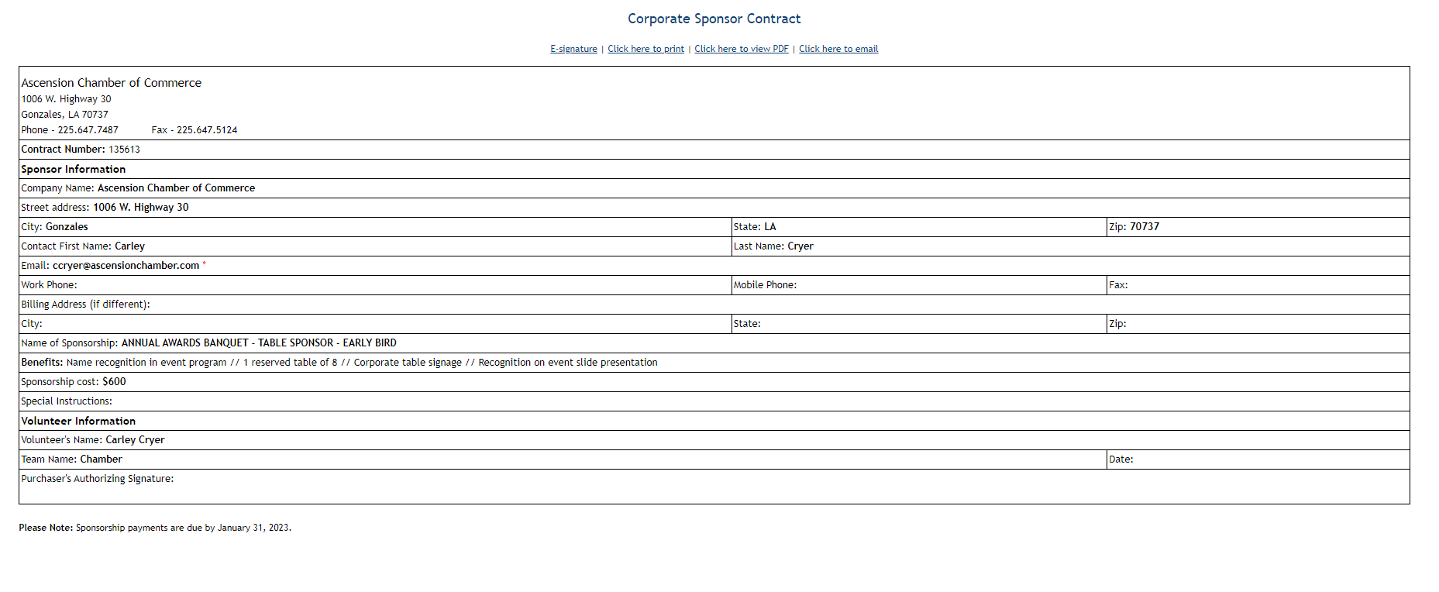
E-SIGNATURE
- This will allow the sponsor to sign using their mouse, so it is very quick for your contacts that are remotely tech-saavy. It will send the contract directly back to me to approve.
- Because this sometimes looks spammy and might be caught by their spam filters, we decided it would be best to ENTER YOUR NAME IN THE EMAIL BOX when creating the contract. That way the contract link will come to your email. I will email you once I approve & enter the sale.
- From there, copy that link and send in a direct email from you to the sponsor contact including whatever wording you chose.
CLICK HERE TO EMAIL
- This option will prompt a pop up box from your email provider with an email from you to your sponsor. From there you can customize the wording.
CLICK HERE TO PRINT OR CLICK HERE TO VIEW PDF
- Can use this route if you want to bring in person OR if you want to save as a PDF and attach in an email.

